Cody Ferre

CSD310-A310

11/11/2023

One function I was enjoying testing was CHECK, this one adds a constraint to your table and allows the user of the database to check it for specific information. For example, I did a check on country to see if it was ‘united states’ or not.

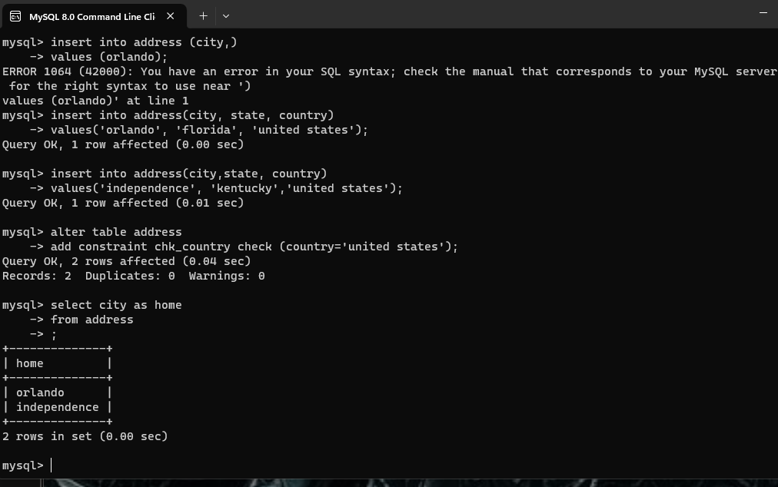

The next function I chose was the ORDER BY function as this one seemed useful when attempting to locate something quickly in alphabetical order. These could make a great use when it comes to accounting software as it helps organize all the data you input quickly and allows for it to be put in a legible order even if by client number or by a necessary location.

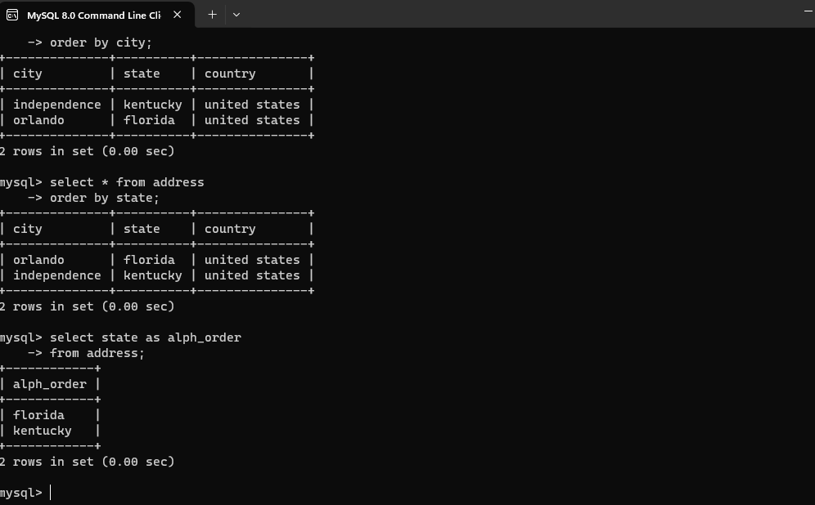

For my final function I found the min() and max() functions which allowed us to find the upper and lower ranges of the tables a great find as it gave a quick way to locate the information as needed and could be an effective method for accounting database again as it would allow for us to find the upper ranges of taxes taken or lower ranges and give a proper ability to give the median for taxes within a corporations database.

